7. Aim: To execute the basic Networking commands
Description:
i. ARP: arp displays and modifies entries in the Address Resolution Protocol (ARP) cache, which contain one or more tables that are used to store IP addresses and their resolved Ethernet or Token Ring physical addresses.
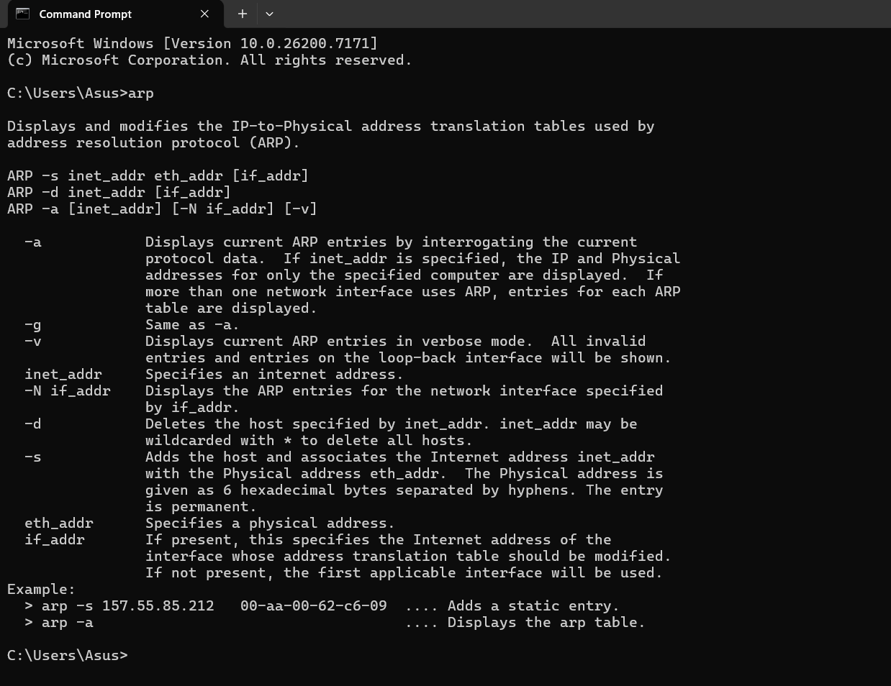
ii. Hostname: The hostname command is the simplest of all the TCP/IP commands. It simply displays the computer's host name.

iii. ipconfig: ipconfig (standing for "Internet Protocol configuration") is a console application program of some computer operating systems that displays all current TCP/IP network configuration values an refreshes Dynamic Host Configuration Protocol (DHCP) and Domain Name System (DNS) settings.
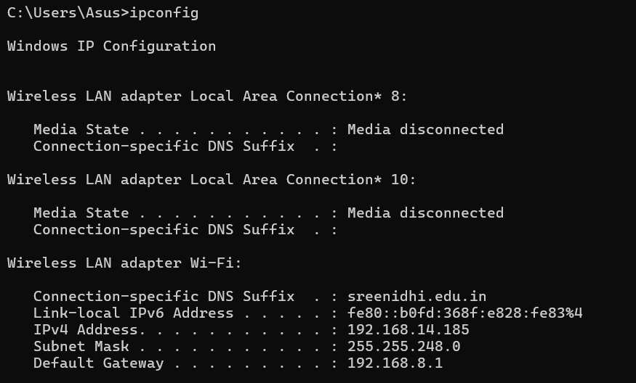
iv. ipconfig/all: Another useful switch with ipconfig is to have it report all TCP/IP network details for all network adapters on a computer. This is accomplished by using the /all switch. This switch provides you with the same basic information as ipconfig described above, but with a lot more detail.
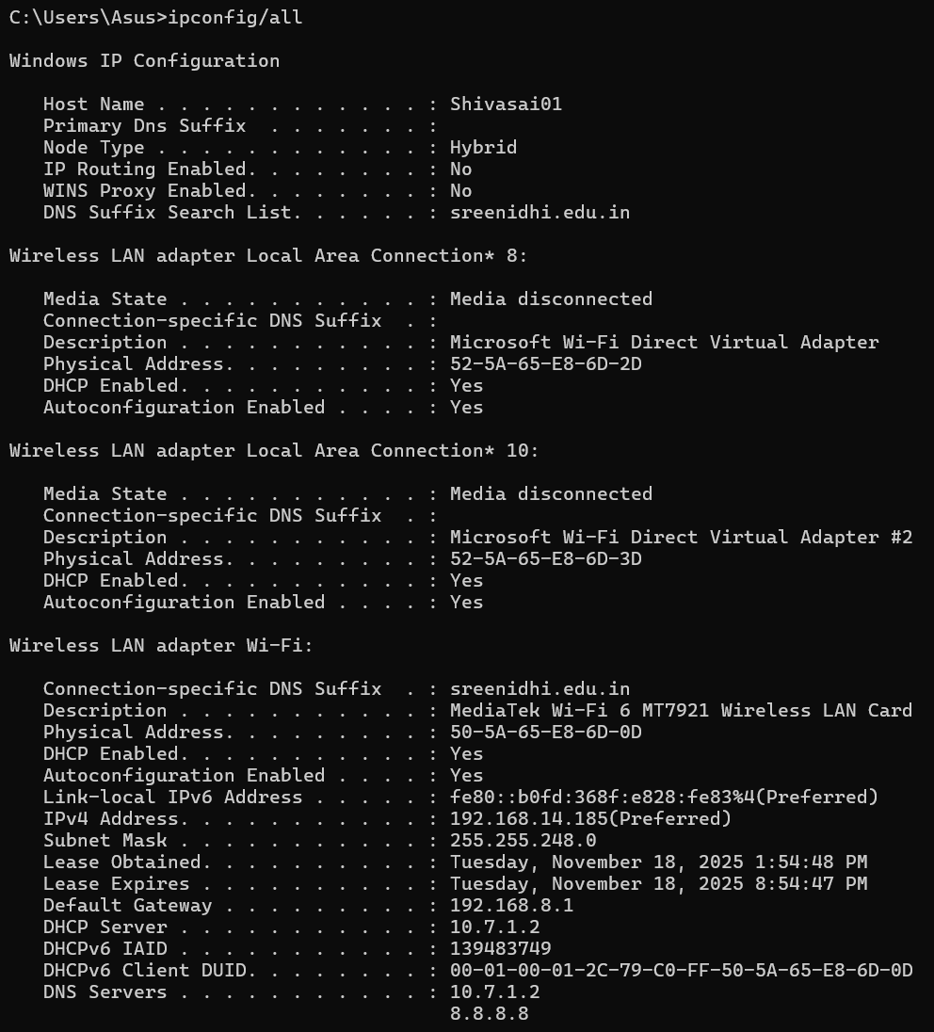
v. ipconfig/renew: The ipconfig /renew will cause your computer to reach out to your DHCP server for an IPv4 address if it doesn't already have one or renews an existing one for all network adapters.
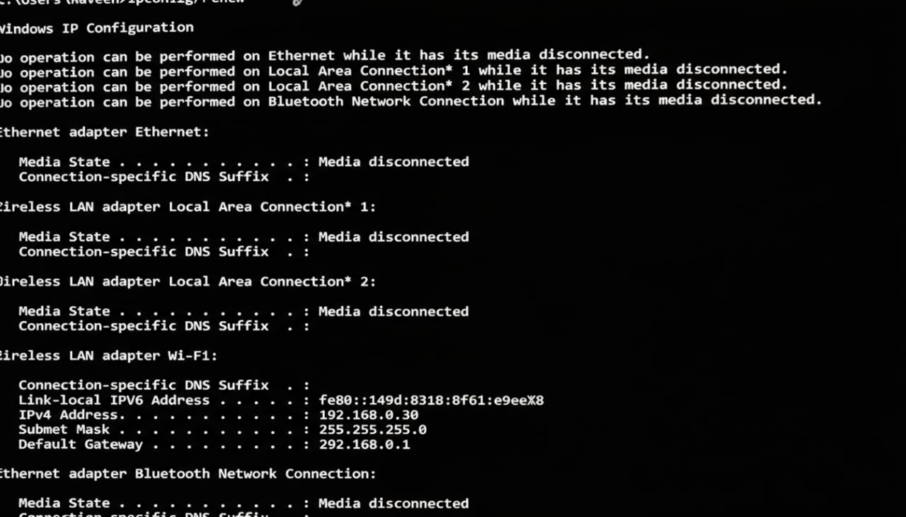
vi. ipconfig/release: The /release switch will cause ipconfig to go through the network adapters you have and drop the dynamically issued IPv4 address by sending a DHCPRELEASE message to the DHCP server.
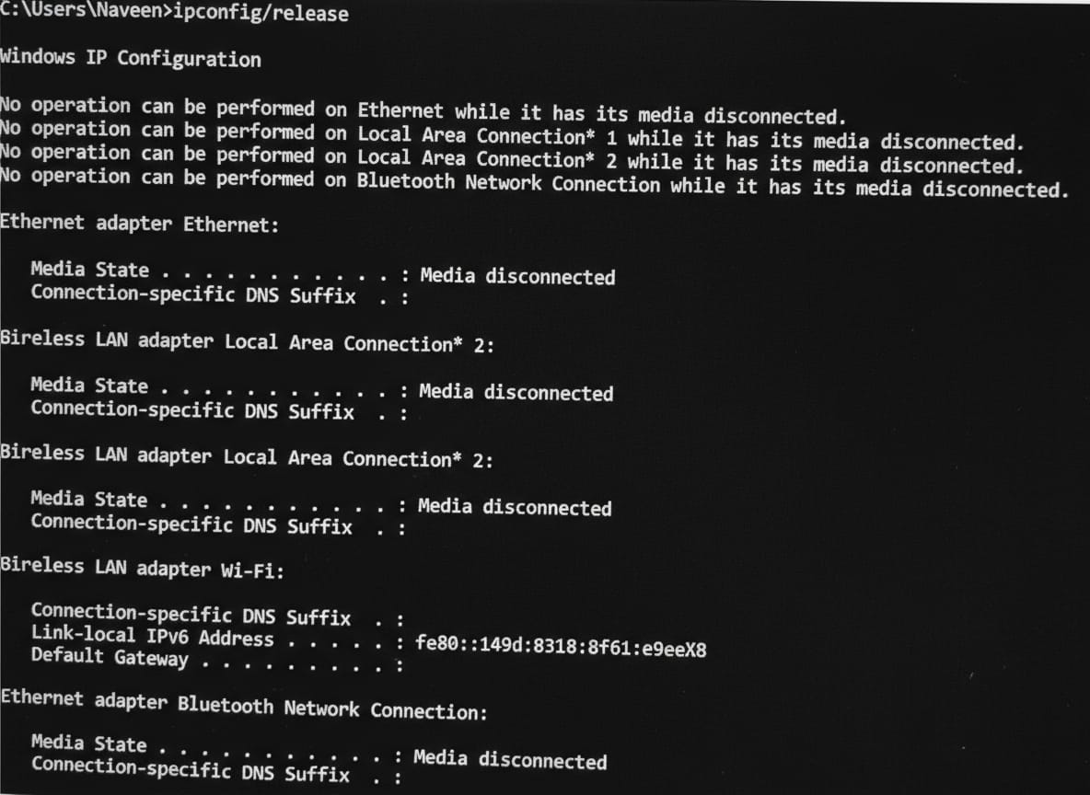
vii. ipconfig/flushdns: This command will purge the cached DNS entries on your computer. You would typically do this to troubleshoot DNS related problems.
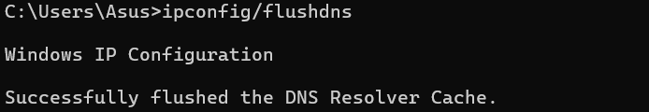
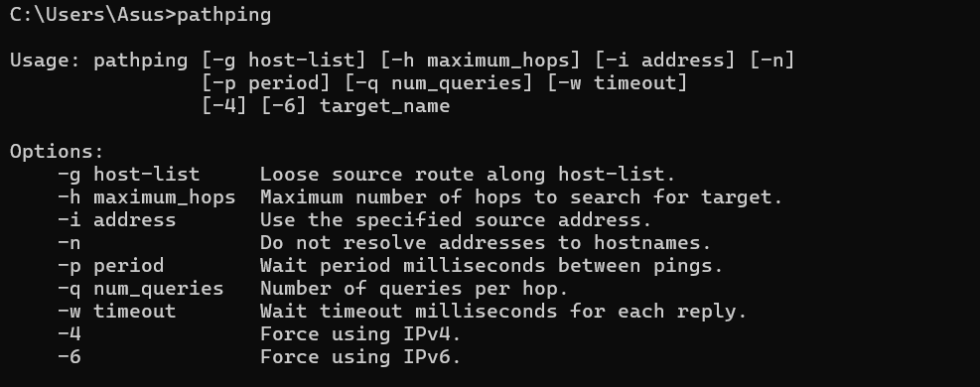
viii. Pathing: It is used to locate spots that have network latency and network loss.

ix. Ping: The ping command sends packets of data to a specific IP address on a network, and then lets you know how long it took to transmit that data and get a response.
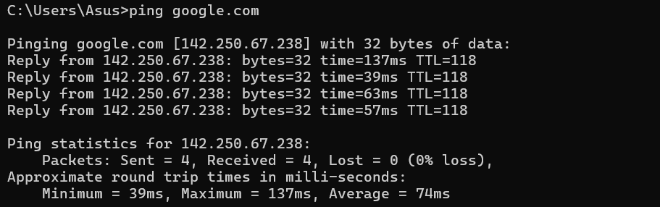
x. Route: The route command allows you to make manual entries into the network routing tables. The route command distinguishes between routes to hosts and routes to networks by interpreting the network address of the Destination variable, which can be specified either by symbolic name or numeric address.
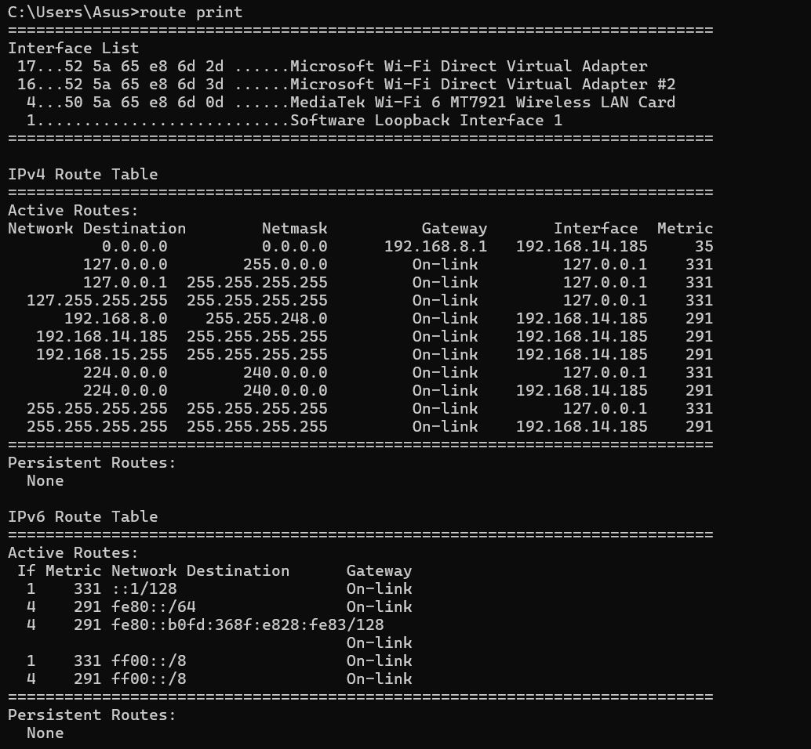
xi. tracert: The Traceroute command (tracert) is a utility designed for displaying the time it takes for a packet of information to travel between a local computer and a destination IP address or domain.
